# CO1417-Explorations in Computing - Week 8

## Topic of this week: Dino Run Project

Student name: Antreas Lamprou

This report provides the Solutions for the assignment given by the lecturers for a functional program with:

* Main Menu
* During the game
* Paused screen
* Losing screen

Resources I have studied and used during this week:

[1] <https://www.cs.cmu.edu/~112/notes/notes-graphics.html>

[2] <https://arxiv.org/ftp/arxiv/papers/1808/1808.09094.pdf>

[3] <https://www.cs.cmu.edu/~15110-n15/labs/lab9/index.html>

[4] <https://python-course.eu/tkinter/canvas-widgets-in-tkinter.php>

[5] <https://docs.python.org/3/library/tkinter.html>

[6] All previous weeks’ materials

[7] <https://www.spriters-resource.com/master_system/theincrediblehulk/sheet/77067/> (Hulk’s animations)

[8] <https://www.peakpx.com/en/hd-wallpaper-desktop-afbvf> (Main Menu picture)

[9] <https://www.spriters-resource.com/arcade/explosivebreaker/sheet/124485/> (Airplanes pictures)

[10] <https://www.spriters-resource.com/pc_computer/simcity2000/sheet/25282/> (Towers pictures)

# Main Menu

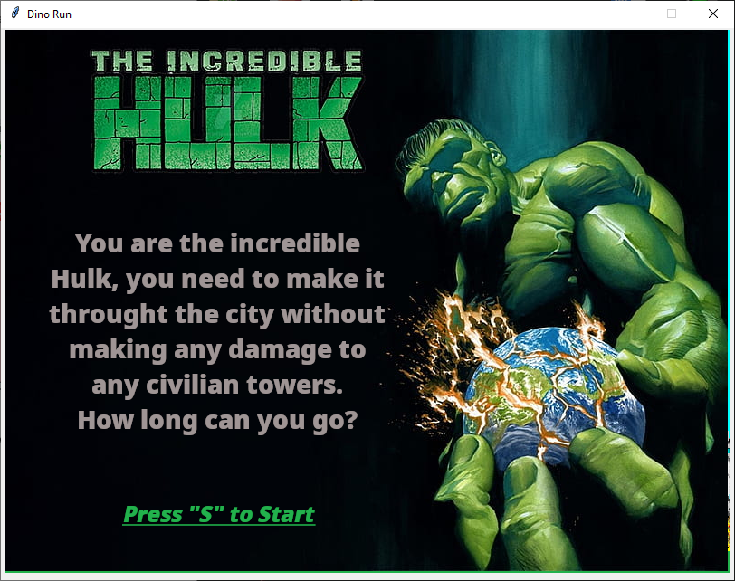

Main menu shows a brief description of the game and states that if the player wants to play, they must type ‘S’.

# When the game runs normally

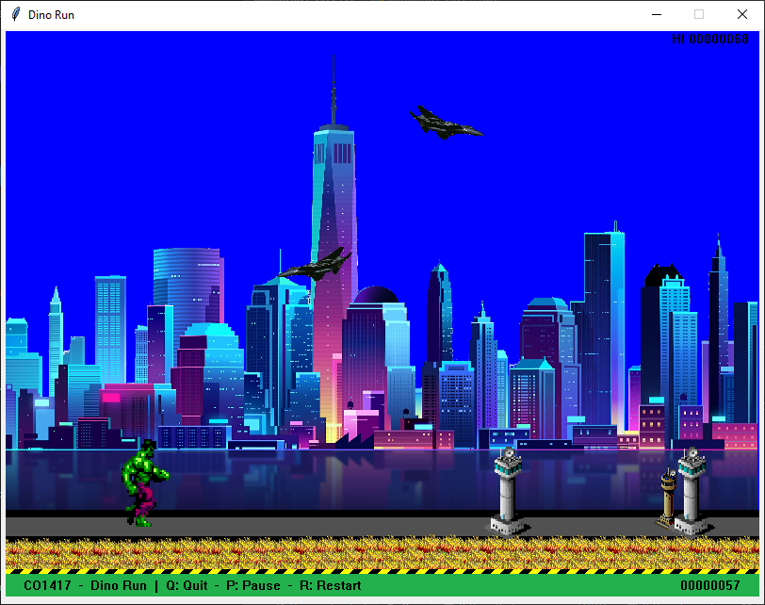

The hulk walks towards the towers and needs to jump over them. O the down right corner is the current score and on the upper right corner is the Highscore.

# When the player pauses

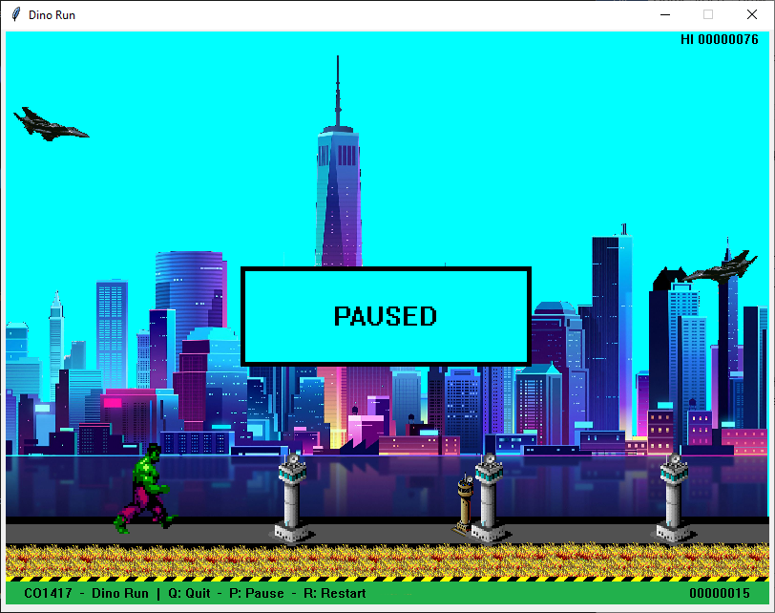

The player pauses and everything stays stable (animations, movements, sky, scores). The player can either restart, resume or exit the game.

# When the player loses

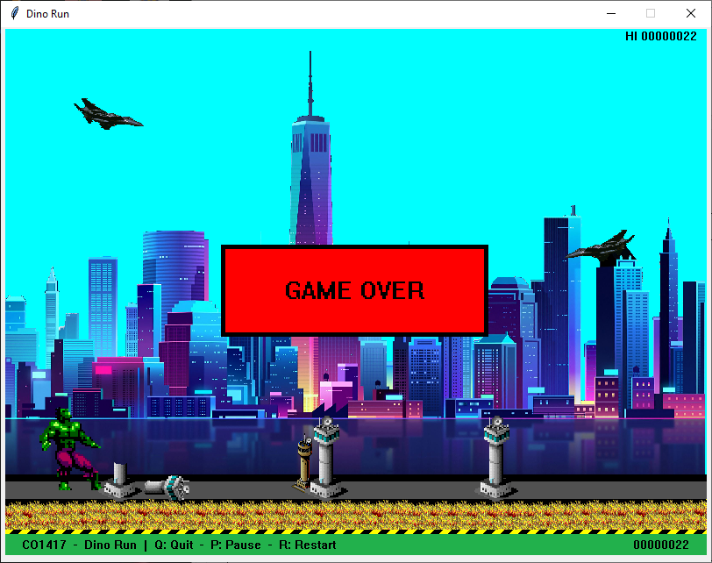

When the player hits a tower, the tower breaks and the hulk animation changes to a ‘hit’ animation. The game stops and the player sees the game over screen. The player can either restart or exit the game